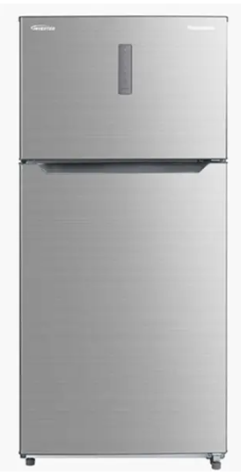

Panasonic French Door Refrigerator
Rs.310,000
Panasonic French Door Refrigerator NR-DZ600GTXN offers 600 litre storage, AI-controlled inverter cooling, and premium stainless styling.

Specifications
- Model: NR-DZ600GTXN
- Capacity: 600 Litres
- Energy Use: 0.58 kWh/day
- Cooling: Panasonic Inverter with AI

Key Features
- NanoHealth deodorizing
- Holiday mode
- Quick freeze
- Digital temperature control

